NAME : PATEL UMEME AIMAN ABDUL WAHID
ROLL NO : 22DCO05
BATCH 01

PRACTICAL NO : 01

AIM : WRITE CASE STUDY ON ARCHITECTURE AND DESIGN OF 8086 MICROPROCESSOR AND IT’S DESIGN

8086 Microprocessor is an enhanced version of 8085Microprocessor that was designed by Intel in 1976. It is a 16-bit Microprocessor having 20 address lines and16 data lines that provides up to 1MB storage. It consists of powerful instruction set, which provides operations like multiplication and division easily.
It supports two modes of operation, i.e. Maximum mode and Minimum mode. Maximum mode is suitable for system having multiple processors and Minimum mode is suitable for system having a single processor.
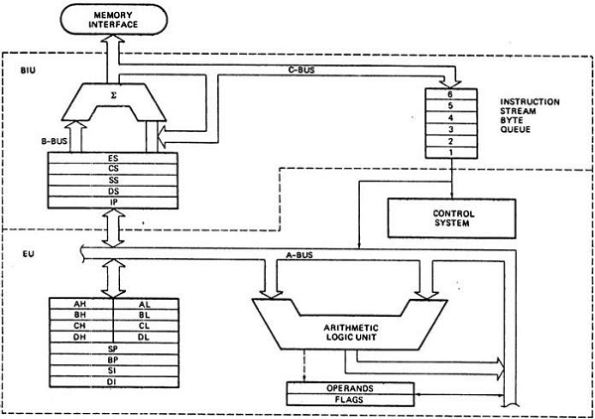

EU (Execution Unit)
Execution unit gives instructions to BIU stating from where to fetch the data and then decode and execute those instructions.

ALU
It handles all arithmetic and logical operations, like +, −, ×, /, OR, AND, NOT operations.

Flag Register
It is a 16-bit register that behaves like a flip-flop, i.e. it changes its status according to the result stored in the accumulator.

Carry flag − This flag indicates an overflow condition for arithmetic operations.

Auxiliary flag − When an operation is performed at ALU, it results in a carry/barrow from lower nibble (i.e. D0 – D3) to upper nibble (i.e. D4 – D7),

Parity flag − This flag is used to indicate the parity of the result.

Zero flag − This flag is set to 1 when the result of arithmetic or logical operation is zero else it is set to 0.

Sign flag − This flag holds the sign of the result, i.e. when the result of the operation is negative, then the sign flag is set to 1 else set to 0.

Overflow flag − This flag represents the result when the system capacity is exceeded.

Control Flags
Control flags controls the operations of the execution unit. Following is the list of control flags −
Trap flag − It is used for single step control and allows the user to execute one instruction at a time for debugging. If it is set, then the program can be run in a single step mode.
- Interrupt flag − It is an interrupt enable/disable flag, i.e. used to allow/prohibit the interruption of a program. It is set to 1 for interrupt enabled condition and set to 0 for interrupt disabled condition.
- Direction flag − It is used in string operation. As the name suggests when it is set then string bytes are accessed from the higher memory address to the lower memory address and vice-a-versa.

General purpose register
There are 8 general purpose registers, i.e., AH, AL, BH, BL, CH, CL, DH, and DL. These registers can be used individually to store 8-bit data and can be used in pairs to store 16bit data. The valid register pairs are AH and AL, BH and BL, CH and CL, and DH and DL. It is referred to the AX, BX, CX, and DX respectively.
- AX register − It is also known as accumulator register. It is used to store operands for arithmetic operations.
- BX register − It is used as a base register. It is used to store the starting base address of the memory area within the data segment.
- CX register − It is referred to as counter. It is used in loop instruction to store the loop counter.
- DX register − This register is used to hold I/O port address for I/O instruction.

BIU (Bus Interface Unit)
BIU takes care of all data and addresses transfers on the buses for the EU like sending addresses, fetching instructions from the memory, reading data from the ports and the memory as well as writing data to the ports and the memory. EU has no direction connection with System Buses so this is possible with the BIU. EU and BIU are connected with the Internal Bus.

